Sumber :
- Buku [0]
- Slide [1]
- http://www.gripinit.com/2015/03/02/depth-height-level-of-a-node/ [2]
- http://stackoverflow.com/questions/2603692/what-is-the-difference-between-tree-depth-and-height [3]
- http://en.wikipedia.org/wiki/Tree_%28data_structure%29 [4]
- http://typeocaml.com/2014/11/26/height-depth-and-level-of-a-tree/ [5]

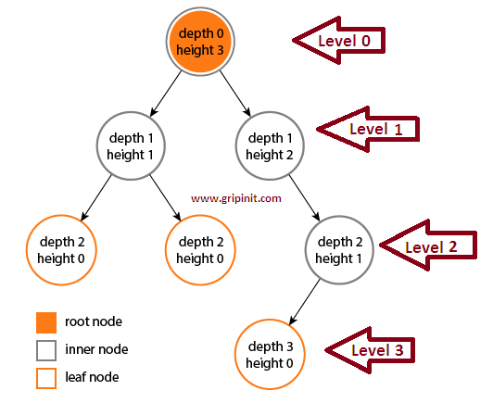
- Level : [0] & [2]
Root level = level 0
The rest : parent’s level + 1

- DEPTH of Node: [2]
The depth is calculated by traversing from root to the given node. [0] & [2]
The depth of a node is the number of edges from the node to the tree’s root node.
e.g. : A root node will have a depth of 0.

- HEIGHT of Node : [2]
The height is calculated by traversing from the given node to deepest leaf.
The height of a node is the number of edges on the longest path from the node to a leaf.
e.g : A leaf node will have a height of 0.

- HEIGHT / DEPTH of Tree : [0]
The total number of nodes on the path from the root node to the deepest node in the tree.
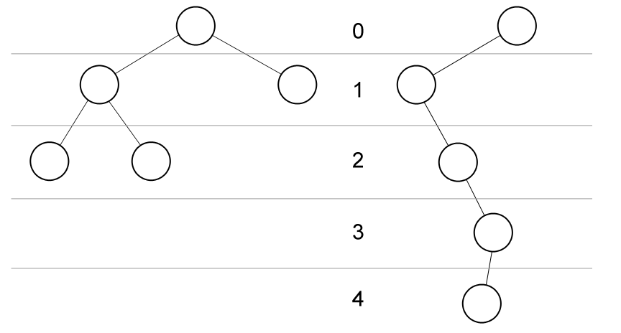
Height / depth of tree : 2 & 4
- HEIGHT In AVL , [1] -> will be learnt in AVL (after mid)
- Height of a tree / subtree :
  - The height of an empty sub tree is 0.
  - The height of a leaf is 1.
  - The height of an internal node is the maximum height of its children plus 1.

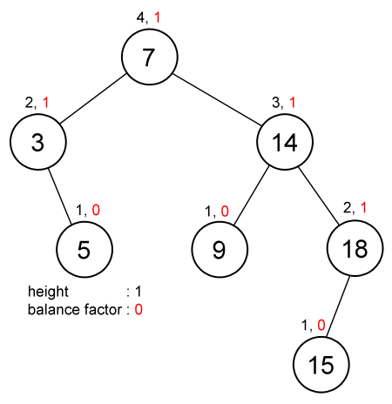

- A binary tree of height h has : [1]
- At least h+1 nodes
- At most 2^{h+1} - 1nodes
e.g :
h = 3
at least 4 nodes
at most 15 nodes

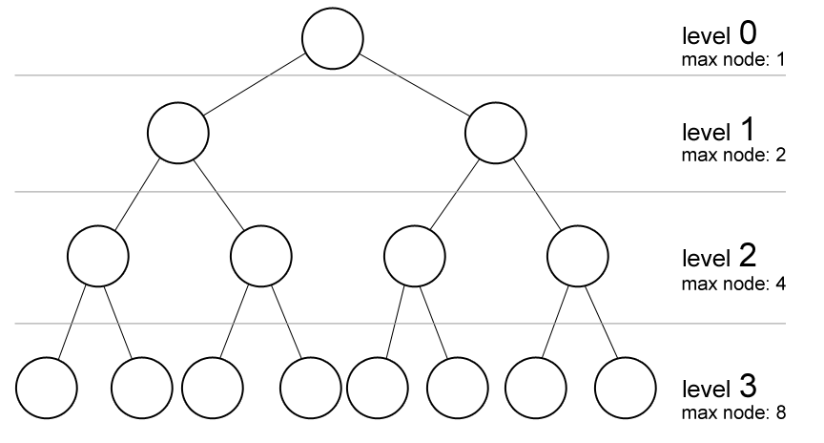

- The height of a binary tree with n nodes is : [1]
- at least 2 log (n) height
- at most n – 1 height
- @ Complete Binary Tree : CEIL(log₂(n))-1
  - E.G : 15 nodes,
H = CEIL(log₂ (15))-1
= CEIL(log₂ (15))- 1 = CEIL(3.9)- 1
= 4 - 1
= 3
  - E.G : 11 nodes,
H = CEIL(log2 (11))-1
= CEIL(3.58)- 1
= 4 - 1
= 3
e.g. :
n = 5
at least 2 height
at most 4 height
@ Complete Binary Tree : ceil(2.23) – 1 = 2


- LEVEL of Node: [2]
The level of a tree as the number of parent nodes a tree node has.
e.g :
The root of the tree, is at level 0.
Root’s children are at level 1, etc.
Maximum number of nodes on level k of a binary tree is 2^{k}.

In some literatures, level of binary tree starts with 1 at (root) or depth + 1 [4] & [5]

